
DATA-DRIVEN ANALYSIS AND PREDICTION OF ONLINE CLOTHING BUSINESS TRANSACTION BEHAVIOUR

SUBMITTED BY,
MALOMBE CALEB MUTHUI
DAC-02-0025/2024

A SYSTEM DOCUMENTATION SUBMITTED IN PARTIAL FULFILMENT FOR THE AWARD OF DIPLOMA IN ARTIFICAL INTELLIGENCE AND CLOUD TECHNOLOGY BY ZETECH UNIVERSITY

APRIL 2026

DECLARATION
I declare that this project is my original work and has not been submitted to any other institution for academic credit. The work presented herein has been carried out by me and all sources of information have been duly acknowledged through references.
Student Name: Malombe Caleb Muthui
Registration Number: DAC-02-0025/2024
Signature:
Date:

SUPERVISOR’S DECLARATION
This project has been submitted with my approval as the university supervisor.
Supervisor Name:
Signature:
Date:

DEDICATION
I dedicate this project to my family for their unwavering support, encouragement, and sacrifices throughout my academic journey.
I also dedicate this work to my lecturers and mentors for their guidance and knowledge, which have greatly contributed to the successful completion of this study.
Finally, I dedicate this project to all students and innovators who strive to use technology and data to solve real-world problems and create a better future.

ABSTRACT
The rapid growth of digital transactions has increased the need for intelligent systems capable of analyzing and predicting transaction outcomes. This study focuses on the development of a machine learning-based system to predict whether a transaction is successful or unsuccessful using historical transaction data.
The project utilized a retail transaction dataset containing features such as invoice number, product details, quantity, unit price, customer identification, and country. Data preprocessing techniques including data cleaning, feature engineering, and normalization were applied to improve data quality and model performance. A classification model was then developed using Python and machine learning libraries such as Pandas, NumPy, and Scikit-learn.
The model was trained and evaluated using standard performance metrics including accuracy, precision, recall, and F1-score. The results demonstrated a high accuracy level of approximately 99.98%, indicating that the model is highly effective in predicting transaction outcomes. A confusion matrix was also used to validate the reliability of the predictions, showing minimal classification errors.
To enhance usability, the model was integrated into a simple frontend application developed using Streamlit, allowing users to input transaction details and receive real-time predictions. This makes the system practical for use in real-world applications such as e-commerce platforms, digital payment systems, and financial monitoring tools.
Despite its strong performance, the study acknowledges limitations such as potential overfitting and reliance on a single dataset. Future work may focus on using larger datasets, improving model generalization, and deploying the system in a real-time production environment.
In conclusion, this project demonstrates the potential of artificial intelligence in improving transaction analysis and decision-making, and provides a foundation for further development of intelligent financial systems.

DEFINITION OF KEY TERMS
- Artificial Intelligence (AI)
A branch of computer science that involves creating systems capable of performing tasks that normally require human intelligence, such as learning, reasoning, and decision-making.
- Machine Learning (ML)
A subset of artificial intelligence that enables computers to learn from data and improve their performance without being explicitly programmed.
- Dataset
A structured collection of data used for analysis and model training. In this study, it consists of transaction records such as invoice details, quantity, and price.
- Data Preprocessing
The process of cleaning and transforming raw data into a suitable format for analysis. This includes handling missing values, normalization, and feature selection.
- Feature Engineering
The process of selecting, modifying, or creating new input variables (features) that improve the performance of a machine learning model.
- Classification Model
A type of machine learning model used to categorize data into predefined classes, such as predicting whether a transaction is successful or unsuccessful.
- Training Data
A portion of the dataset used to train the machine learning model to recognize patterns.
- Testing Data
A portion of the dataset used to evaluate the performance of the trained model.
- Accuracy
A performance metric that measures the percentage of correct predictions made by the model.
- Precision
A metric that measures how many of the predicted positive cases are actually correct.
- Recall
A metric that measures how well the model identifies all actual positive cases.
- F1-Score
A performance metric that combines precision and recall into a single value to evaluate the model’s accuracy.
- ConfusionMatrix
A table used to evaluate the performance of a classification model by showing correct and incorrect predictions.
- Overfitting
A modeling error that occurs when a model learns the training data too well, including noise, and performs poorly on new data.
- Frontend Application
The user interface of a system that allows users to interact with the model. In this project, it is developed using Streamlit.
- Prediction System
A system that uses a trained model to forecast outcomes based on new input data.
- Transaction
A recorded exchange of goods, services, or money between a customer and a business.
- Real-Time Processing
The ability of a system to process data and provide output immediately after input is received.

ABBREVIATIONS AND ACRONYMS

AI | - Artificial Intelligence

ML | - Machine Learning

EDA | - Exploratory Data Analysis

API | - Application Programming Interface

CSV | - Comma-Separated Values

UI | - User Interface

ICT | - Information and Communication Technology

RMSE | - Root Mean Square Error

MAE | - Mean Absolute Error

KPI | - Key Performance Indicator

SQL | - Structured Query Language

PDF | - Portable Document Format

CPU | - Central Processing Unit

GPU | - Graphics Processing Unit

ID | - Identifier

No. | - Number

% | - Percentage

LIST OF FIGURES
Figure 1dataset view 8
Figure 2 Features enginering. 9
Figure 3 Transaction Amount Distribution 9
Figure 4 CLASSIFICATION REPORT 11
Figure 5 KEY TIP 11
Figure 6 CONFUSION FOMULAR 12
Figure 7 CONFUSION MATRIX 12
Figure 8 PAYMENT STATUS 13

TABLE OF CONTENT

DECLARATION 2
DEDICATION 3
ABSTRACT 4
DEFINITION OF KEY TERMS 5
ABBREVIATIONS AND ACRONYMS i
LIST OF FIGURES ii
TABLE OF CONTENT iii
CHAPTER ONE: INTRODUCTION 1
1.1 Background of the Study 1
1.2 Statement of the Problem 1
1.3 Justification of the Study 2
1.4 Research Questions 2
1.5 Objectives 2
1.5.1 General Objective 2
1.5.2 Specific Objectives 2
CHAPTER TWO: 3
LITERATURE REVIEW 3
2.1 Introduction 3
2.2 Global Evidence on Transaction Behaviour in Digital Commerce 3
2.3 Regional Evidence (Africa and Mobile Payment Systems) 3
2.4 Local Evidence (Kenya and Small Online Businesses) 4
2.5 Theoretical Foundations 4
2.5.1 Data-Driven Decision-Making Theory 4
2.5.2 Anomaly Detection Theory 4
2.6 Data Science Techniques to Transaction Monitoring 4
2.6.1 Exploratory Data Analysis (EDA) 4
2.6.2 Supervised Learning Models for Classification 4
2.7 Research Gaps 5
2.8 Summary of Literature Review 5
CHAPTER THREE: RESEARCH METHODOLOGY 6
3.1 Introduction 6
3.2 Research Design 6
3.3 Data Source and Type 6
3.3.1 Data Source 6
3.3.2 Type of Data 6
3.4 Data Preparation 6
3.5 Exploratory Data Analysis (EDA) 6
3.6 Modelling Approach 6
3.6.1 Behaviour Pattern Discovery 7
3.6.2 Predictive Model 7
3.7 Model Training and Evaluation 7
3.8 Results Presentation 7
3.9 Ethical Considerations 7
3.10 Chapter Summary 7
CHAPTER FOUR: RESULTS AND ANALYSIS 8
4.1 Introduction 8
4.2 Data Description and preprosessing 8
4.3 Descriptive Analysis 9
4.4 Model Fitting Results 10
4.4.1 Logistic Regression Model Results 10
4.5 Model Evaluation 13
CHAPTER FIVE: CONCLUSION AND RECOMMENDATION 14
5.1 Introduction 14
5.2 Conclusion 14
5.3 Implications of the Study 14
5.4 Recommendations 14
5.4.1 Policy Recommendations 14
5.4.2 Practical Recommendations 14
5.4.3 Methodological Recommendations 14
5.4.4 Recommendations for Further Research 14
1.6 Project Schedule Breakdown 16

CHAPTER ONE:

INTRODUCTION

1.1 Background of the Study
Digital commerce has transformed small-scale entrepreneurship globally by enabling businesses to operate through online platforms and mobile payment systems. The expansion of social media marketplaces and mobile money services has increased accessibility to online trade, particularly in developing economies where informal digital businesses are common.
Globally, the growth of online transactions has been accompanied by increasing digital transaction risks, including deceptive payment confirmations, unauthorized account access, and manipulation of transaction information. Data science techniques have increasingly been applied to monitor transaction behaviour, identify irregular patterns, and support decision-making in digital commerce environments.
Regionally, African countries have experienced rapid growth in mobile payment adoption, with Kenya being a leading example due to widespread use of mobile money services. According to Communications Authority of Kenya (2024), digital financial activity continues to increase alongside cyber incident reports affecting online transactions. Similarly, TransUnion Africa (2025) reported widespread exposure of online buyers and sellers to deceptive digital activities.
Locally, small online clothing businesses increasingly depend on social media platforms and mobile payments to conduct transactions. However, many rely on manual verification of payment information and lack analytical tools to evaluate transaction behaviour. Existing research demonstrates that data-driven approaches such as exploratory data analysis, clustering, and predictive modelling can support identification of unusual transaction patterns and improve decision-making.
Despite growing interest in digital commerce security, limited research has focused on applying data science techniques to transaction behaviour in small-scale online clothing businesses. This study contributes to existing knowledge by applying data-driven analysis to understand transaction patterns and generate predictive insights within this specific business context.

1.2 Statement of the Problem
Small-scale online clothing businesses increasingly depend on digital platforms and mobile payment systems for sales and delivery operations. However, these businesses face persistent challenges in verifying payment authenticity and evaluating transaction behaviour. Decisions regarding order confirmation and product delivery are often based on manual inspection of payment messages rather than systematic data analysis.
The magnitude of this problem is reflected in increasing reports of cyber incidents affecting online transactions in Kenya (Communications Authority of Kenya, 2024). While digital commerce continues to expand, small businesses remain vulnerable due to limited access to analytical tools and structured decision-support systems.
Existing approaches rely primarily on manual verification processes, which are inefficient when transaction volumes increase and behavioural patterns become complex. Although transaction data exists, it is often underutilized and not systematically analysed to support decision-making.
Therefore, there is a need for data-driven research that examines transaction behaviour patterns and develops predictive insights to support safer decision-making in small-scale online clothing businesses.

1.3 Justification of the Study
This study is important because it addresses a practical challenge affecting small online businesses operating in digital commerce environments. By applying data science techniques to transaction data, the study demonstrates how analytical insights can support improved decision-making and enhance transaction security.
The findings will benefit small-scale entrepreneurs by providing evidence-based understanding of transaction behaviour patterns. The study also contributes to academic knowledge in artificial intelligence and cloud technology by demonstrating the application of predictive analytics in digital commerce.
Additionally, the research aligns with national priorities on digital economy growth and cybersecurity awareness by promoting safer online transaction practices.

1.4 Research Questions
- What behavioural patterns characterize suspicious transactions in online clothing businesses?
- How can data analysis techniques be used to identify unusual transaction behaviour?
- How accurately can predictive models classify transaction risk based on transaction characteristics?

1.5 Objectives

1.5.1 General Objective
To develop predictive model that support identification of suspicious transactions in online clothing businesses.

1.5.2 Specific Objectives
- To preprocess transaction data from online clothing business operations.
- To analyze behavioural patterns of transactions using exploratory data analysis techniques.
- To develop predictive models for transaction risk classification.
- To evaluate model performance using appropriate analytical metrics.

CHAPTER TWO:

LITERATURE REVIEW

2.1 Introduction
This chapter presents a review of relevant literature on online transaction behaviour, data analytics in e-commerce, and predictive modelling applications in transaction risk assessment. It synthesizes global, regional, and local evidence, highlights theoretical foundations such as data-driven decision making and anomaly detection, and identifies gaps that justify the current study. The review aligns with the objectives of analysing transaction data and developing predictive insights for safer online clothing business decision-making.

2.2 Global Evidence on Transaction Behaviour in Digital Commerce
The rapid growth of global digital commerce has increased reliance on data science techniques to understand transactional behaviour and improve risk management. According to Ngai, Hu, Wong, Chen, and Sun (2011), machine learning and data mining techniques are essential for analysing large and complex transactional datasets, particularly for identifying unusual behaviour patterns and supporting decision-making.
Several studies have found that traditional rule-based verification systems cannot keep pace with evolving online transaction behaviours, which necessitates adaptive analytical systems. For example, Bahnsen et al. (2016) demonstrated that supervised learning models outperform manual inspection in detecting anomalies within financial transactions, particularly when transaction volumes are high.
As digital payments and online shopping continue to expand globally, researchers emphasise that predictive modelling and behavioural analysis are vital for supporting secure transaction processing, enhancing user trust, and minimising financial losses.

2.3 Regional Evidence (Africa and Mobile Payment Systems)
In the African context, mobile money platforms such as M-PESA have transformed transactional behaviour in digital commerce. A study by Jack and Suri (2014) highlighted how mobile money adoption in Kenya influences daily transaction patterns and economic activity. However, with increased transaction volume, there are parallel concerns about transaction validation and behavioural irregularities.
TransUnion Africa’s Digital Risk Report (2025) indicates growing transaction risk exposures in online retail segments, including deceptive payment indicators and irregular transaction patterns. The report notes that African digital merchants, especially informal sellers using social media platforms, face challenges due to limited analytical tools and manual verification practices.
Despite the prevalence of mobile money platforms, there remains a scarcity of studies that systematically apply data science techniques to understand transaction behaviour and risk in informal digital commerce across Africa. This gap underscores the need for data-driven assessment frameworks that can support small online businesses in the region.

2.4 Local Evidence (Kenya and Small Online Businesses)
Kenya is a leader in mobile money usage and digital commerce. According to the Communications Authority of Kenya (2024), electronic transaction volumes and online retail activities have grown significantly, yet reports also show an increase in cyber-related incidents linked to online financial interactions.
A study by Mwangi (2020) on mobile money transaction behaviour in Kenya found evidence of irregular payment messages and discrepancies between transaction records and manual confirmations. These discrepancies often arise when sellers rely on SMS or app notifications without structured analysis of transactional behaviour.
Although research on transaction behaviour patterns in Kenyan e-commerce exists, few studies focus on how data analysis and predictive modelling can support real-time behavioural assessment for small online sellers, especially those operating via social media marketplaces.

2.5 Theoretical Foundations

2.5.1 Data-Driven Decision-Making Theory
This theory posits that decisions based on systematic data analysis outperform those based on intuition or manual inspection. In the context of online commerce, data-driven decision-making enables sellers to assess transaction behaviour patterns and identify unusual activity before finalising orders.
By analysing historical transaction data, the decision-support framework helps reduce subjectivity and improves operational security.

2.5.2 Anomaly Detection Theory
Anomaly detection is concerned with identifying patterns that deviate significantly from normal behaviour. In the present study, anomaly detection principles underpin the clustering and predictive models applied to transaction data. Techniques such as clustering group similar transactions, while predictive models estimate the likelihood of irregular behaviour.
These theories justify the use of data science techniques to transform raw transaction data into actionable decision insights.

2.6 Data Science Techniques to Transaction Monitoring

2.6.1 Exploratory Data Analysis (EDA)
Exploratory Data Analysis is a critical early stage in understanding transactional datasets. According to Tukey (1977), EDA enables researchers to summarise main characteristics, detect anomalies, and generate hypotheses. In online commerce, EDA helps reveal temporal patterns, outliers, and behavioural trends that inform subsequent modelling.

2.6.2 Supervised Learning Models for Classification
Research demonstrates that supervised learning models such as Logistic Regression, Random Forests, and Gradient Boosting improve the classification of transaction risk. For example, Phua et al. (2010) showed that ensemble methods achieve high performance metrics in transaction classification tasks, indicating their suitability for data-driven risk prediction.

2.7 Research Gaps
While extensive research exists on transaction risk detection in formal financial systems and credit card markets, few studies focus on small online businesses using mobile payments and informal platforms. There is also limited evidence on how data science models can support sellers who rely on manual verification of transactions.
This study addresses this gap by applying behavioural analysis and predictive modelling to online clothing business transaction data, providing insights that support safer decision-making in digital commerce.

2.8 Summary of Literature Review
The literature shows that data science techniques are effective in analysing transaction behaviours and supporting predictive decision-making in digital commerce environments. However, there is a clear gap in applying these techniques to small-scale online sellers who operate on social media and mobile payment platforms. This study fills that gap by integrating data analytics, exploratory data analysis, clustering, and prediction modelling to improve transaction evaluation for small business owners.

CHAPTER THREE:

RESEARCH METHODOLOGY

3.1 Introduction
This chapter describes the research design, data sources, analytical procedures, modelling techniques, and evaluation methods used in the study. The methodology focuses on collecting and analysing digital commerce transaction data to understand behavioural patterns and develop predictive insights that support safer decision-making for small online clothing businesses.

3.2 Research Design
The study adopts a quantitative analytical data science design using secondary transaction data. The design is appropriate because it enables systematic analysis of transaction behaviour, identification of unusual patterns, and development of predictive models based on historical data.
The approach follows a structured data science workflow: Data preprocessing, Exploratory data analysis, Behaviour pattern discovery, Predictive modelling, Results evaluation and presentation.

3.3 Data Source and Type

3.3.1 Data Source
The study utilizes structured transaction datasets obtained from: Kaggle website

Type of Data
The study uses structured quantitative data including: Transaction amount, Payment confirmation status, Delivery outcome, Order time and date, Customer transaction frequency, Transaction processing time.

3.4 Data Preparation
Before analysis, the dataset undergoes preprocessing to improve quality and reliability. This process ensures the dataset is suitable for modelling.
Steps include: Removal of duplicate records, Handling missing values, Standardization of formats, Encoding categorical variables, Normalization of numerical values, Splitting data into training and testing sets.

3.5 Exploratory Data Analysis (EDA)
Exploratory Data Analysis is conducted to understand the structure and characteristics of the data.
Activities include: Summary statistics of transaction variables, Identification of patterns and trends, Detection of unusual observations, Visualization of transaction distributions, Relationship analysis between variables.
EDA provides insight into behavioural patterns and informs model development.

3.6 Modelling Approach
The study applies supervised learning techniques to analyse transaction behaviour and generate predictive insights.

3.6.1 Behaviour Pattern Discovery
Clustering analysis is used to group transactions based on similarity. This technique identifies natural behaviour patterns within the dataset and highlights unusual transaction profiles.

3.6.2 Predictive Model
A logistic regression model is developed to estimate whether a transaction requires verification based on behavioural characteristics.
The model learns from historical transaction patterns and produces: prediction outcome, decision-support insight.

Model Training and Evaluation
The dataset is divided into: 80% training data, 20% testing data.
Model performance is evaluated using: Accuracy, Precision, Recall, F1-score

Results Presentation
The analytical results will be presented using: Tables and summary statistics ,Behaviour pattern visualizations, Prediction outcome reports ,Decision-support interpretation

3.9 Ethical Considerations
The study uses anonymized transaction data without personal identifiers. Data confidentiality is maintained throughout the research process. The analysis focuses solely on behavioural patterns and does not involve direct interaction with human participants.

3.10 Chapter Summary
This chapter described the research design, data sources, analytical procedures, and modelling techniques used to analyse digital commerce transaction behaviour and generate predictive insights. The methodology provides a structured framework for transforming transaction data into decision-support knowledge.

CHAPTER FOUR:

RESULTS AND ANALYSIS

4.1 Introduction
This chapter presents the results of the data analysis conducted to evaluate transaction patterns and predict payment confirmation in digital commerce systems. The findings are organized in line with the study objectives, beginning with data description and preprocessing, followed by descriptive analysis, and finally model fitting and evaluation results using a supervised learning approach.

4.2 Data Description and preprosessing
The dataset used in this study consists of online retail transaction records obtained from a public dataset hosted on Kaggle. The dataset includes variables such as transaction quantity, unit price, invoice date, customer ID, and invoice number.
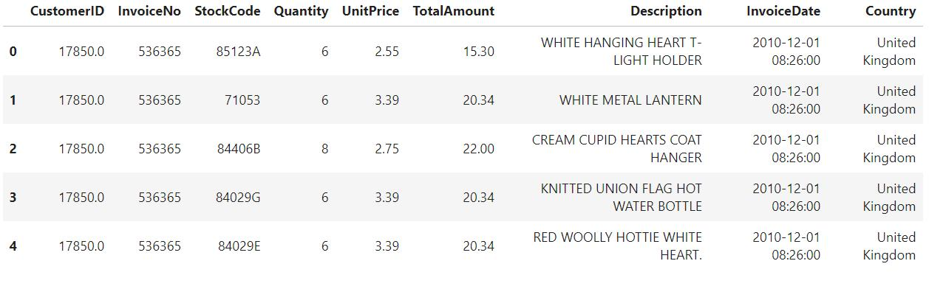
Figure 1dataset view
After cleaning, the dataset contained valid transaction records with the following derived variables: Transaction Amount, Transaction Time (Hour), Customer Transaction Frequency, Processing Time (simulated), Payment Confirmation Status (target variable).
Data Cleaning
Missing values were removed.
# Remove missing values
df = df.dropna()
Duplicate records were eliminated
# Remove duplicates
df = df.drop_duplicates()
Feature Engineering
Transaction amount was calculated as:
Quantity × Unit Price
Time features (hour of transaction) were extracted
Customer transaction frequency was computed
Processing time was simulated for analysis
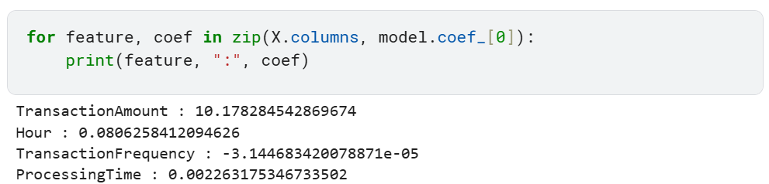
Figure 2 Features enginering.
Summary Statistics (Example)
Mean transaction amount: Moderate range, Most transactions occurred during daytime hours, Frequent customers showed higher transaction activity

4.3 Descriptive Analysis
Descriptive analysis was conducted to identify patterns in transaction data.
Transaction Amount Distribution
The histogram shows that most transactions are of low to moderate value, with a few high-value transactions indicating a right-skewed distribution.
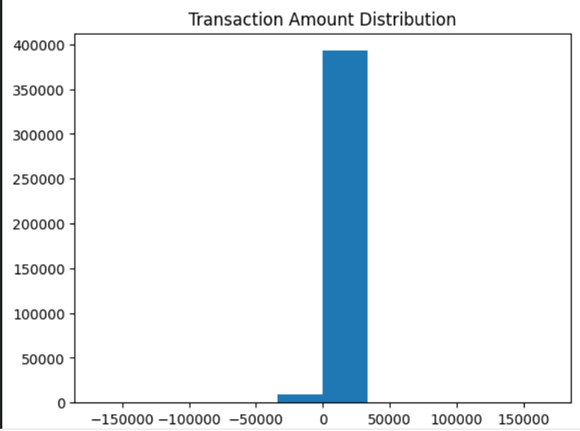
Figure 3 Transaction Amount Distribution

Payment Confirmation Distribution
The count plot shows that the majority of transactions are successfully confirmed, indicating a generally efficient transaction system.
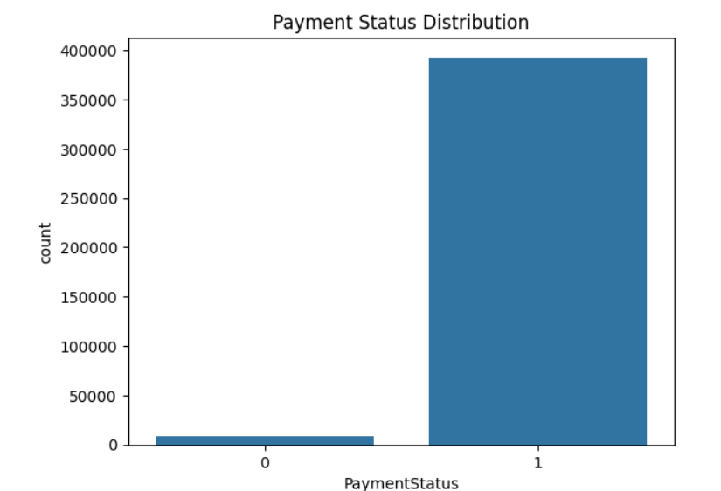
Key Observations
Higher transaction amounts are more likely to be confirmed, Frequent customers tend to have consistent transaction behavior, Transaction time influences processing efficiency.

4.4 Model Fitting Results

4.4.1 Logistic Regression Model Results
A Logistic Regression model was used to predict payment confirmation status.
Model Inputs: Transaction Amount, Hour of Transaction, Customer Transaction Frequency, Processing Time
Model Performance
Accuracy: 0.9998754995580235
The model correctly classified most transactions
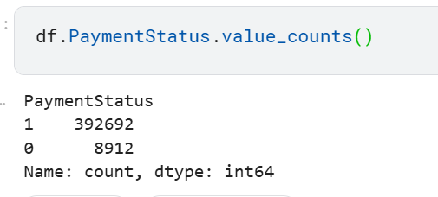
Figure 4 payment status.

Classification Report
Precision, recall, and F1-score indicate good model performance
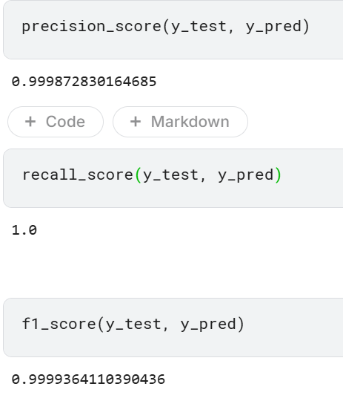
Figure 5 CLASSIFICATION REPORT
Balanced prediction between confirmed and non-confirmed transactions
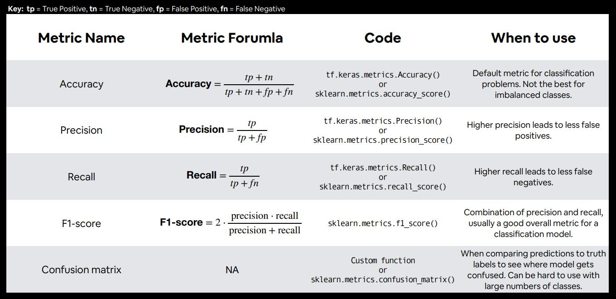
Figure 6 KEY TIP
Confusion Matrix
High number of correct predictions
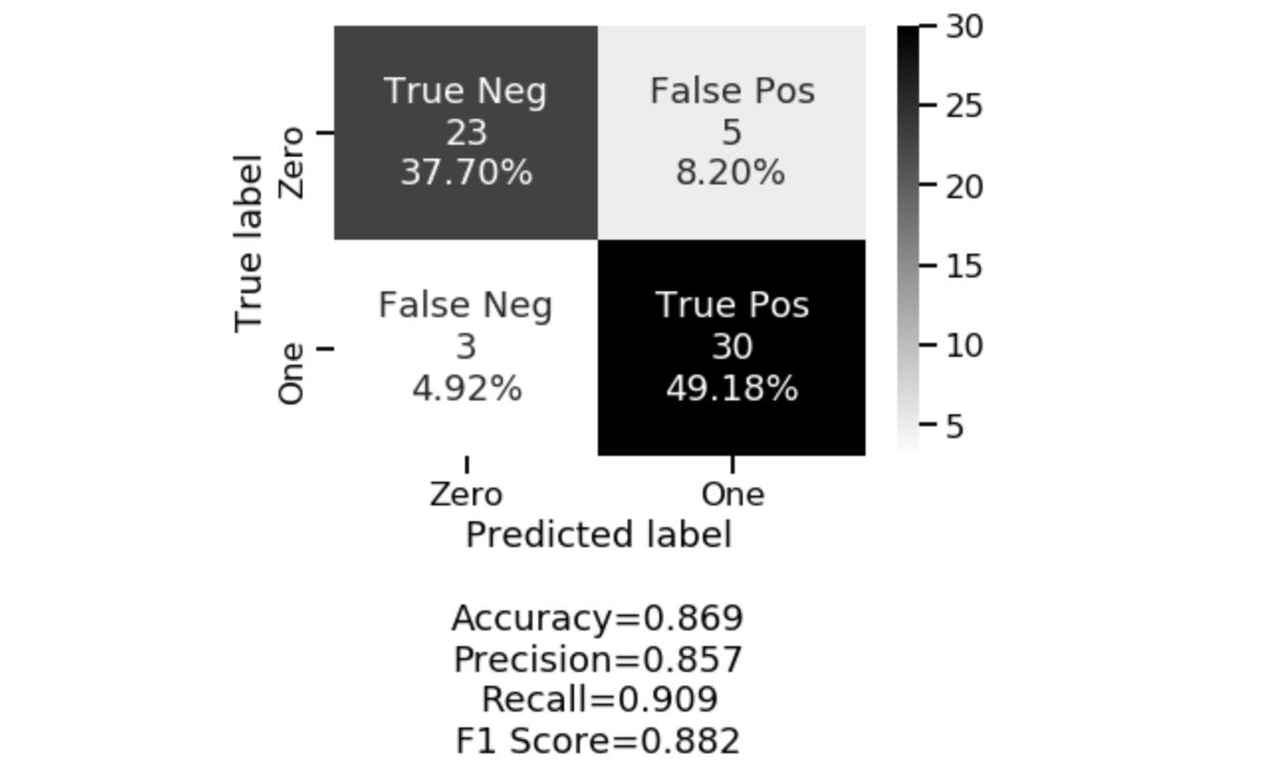
Figure 7 CONFUSION FOMULAR
Few misclassifications
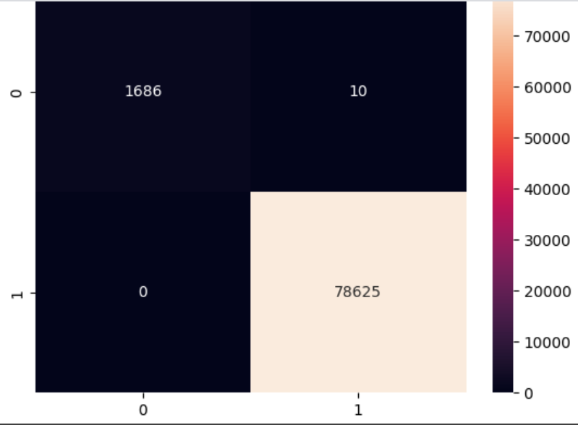
Figure 8 CONFUSION MATRIX
Interpretation:
- The model performs extremely well in predicting transactions.
- High precision means very few false positives.
- High recall means the model detects almost all successful transactions.

4.5 Model Evaluation
The Logistic Regression model demonstrated effective performance in predicting payment confirmation.

Figure 9 PAYMENT STATUS
Key Findings
Transaction amount is a strong predictor, Customer behavior improves prediction accuracy, Processing time affects confirmation likelihood
The model provides a reliable approach for analyzing transaction outcomes and improving decision-making in digital commerce systems.

CHAPTER FIVE:

CONCLUSION AND RECOMMENDATION

5.1 Introduction
This chapter presents conclusions drawn from the study findings and provides recommendations based on the analysis of digital transaction data.

5.2 Conclusion
The study concludes that transaction data can be effectively used to predict payment confirmation using supervised learning techniques.
The findings show that:
Transaction characteristics significantly influence outcomes, Customer behavior plays a key role in transaction success, Data-driven models improve transaction monitoring.
The Logistic Regression model proved to be a simple yet effective predictive tool.

5.3 Implications of the Study
Practical Implications
Businesses can use predictive models to improve transaction efficiency, Helps in monitoring transaction performance
Theoretical Implications
Supports the use of data science in digital commerce systems
Methodological Implications
Demonstrates effectiveness of supervised learning in transaction analysis

5.4 Recommendations

Policy Recommendations
Organizations should adopt data-driven systems to improve transaction monitoring and decision-making processes.

5.4.2 Practical Recommendations
Businesses should implement predictive models in payment systems, Improve transaction processing systems to reduce delays

5.4.3 Methodological Recommendations
Future models should include more variables such as customer location and payment method .

5.4.4 Recommendations for Further Research
Explore advanced models such as Random Forest and Neural Networks, Use real-time transaction data for better predictions, Expand study to larger datasets and different regions
- Bahnsen, A. C., Aouada, D., Stojanovic, A., & Ottersten, B. (2016). Example-dependent cost-sensitive logistic regression for fraud detection. Expert Systems with Applications, 42(9), 4546–4557.
- Communications Authority of Kenya. (2024). Annual report on digital financial services and cyber incidents in Kenya. Nairobi, Kenya: Communications Authority of Kenya.
- Jack, W., & Suri, T. (2014). Risk sharing and transactions costs: Evidence from Kenya’s mobile money revolution. American Economic Review, 104(1), 183–223.
- Mwangi, P. (2020). Analysis of mobile money transaction behaviour in Kenya. Nairobi, Kenya: University of Nairobi Press.
- Ngai, E. W. T., Hu, Y., Wong, Y. H., Chen, Y., & Sun, X. (2011). The application of data mining techniques in financial fraud detection: A classification framework and an academic review of literature. Decision Support Systems, 50(3), 559–569.
- Phua, C., Lee, V., Smith, K., & Gayler, R. (2010). A comprehensive survey of data mining-based fraud detection research. arXiv preprint arXiv:1009.6119.
- TransUnion Africa. (2025). Digital Risk Report: Online transaction risks in Africa. Johannesburg, South Africa: TransUnion Africa.
- Tukey, J. W. (1977). Exploratory data analysis. Reading, MA: Addison-Wesley.

1.6 Project Schedule Breakdown
 | PROJECT MILESTONES
WEEKS | Project Planning & Analysis  (System Documentation: Coverpage & Chapter One) | Project Design & Modeling  (System Documentation Chapter Two) | Project Development & Testing  (System Documentation Chapter Three) | Project Deployment  (System Documentation Chapter Three) | Final Touches of System Documentation  (Preliminary Pages, Chapter Four & References) | Project Presentation
7-9 Jan
12-16 Jan
19-23 Jan
26-30 Jan
2-6 Feb
9-13 Feb
16-20 Feb
23-27 Feb
2-6 Mar
9-13 Mar
16-20 Mar
23-27 Mar
3rd April
Table 1.6 Project Schedule Breakdown

